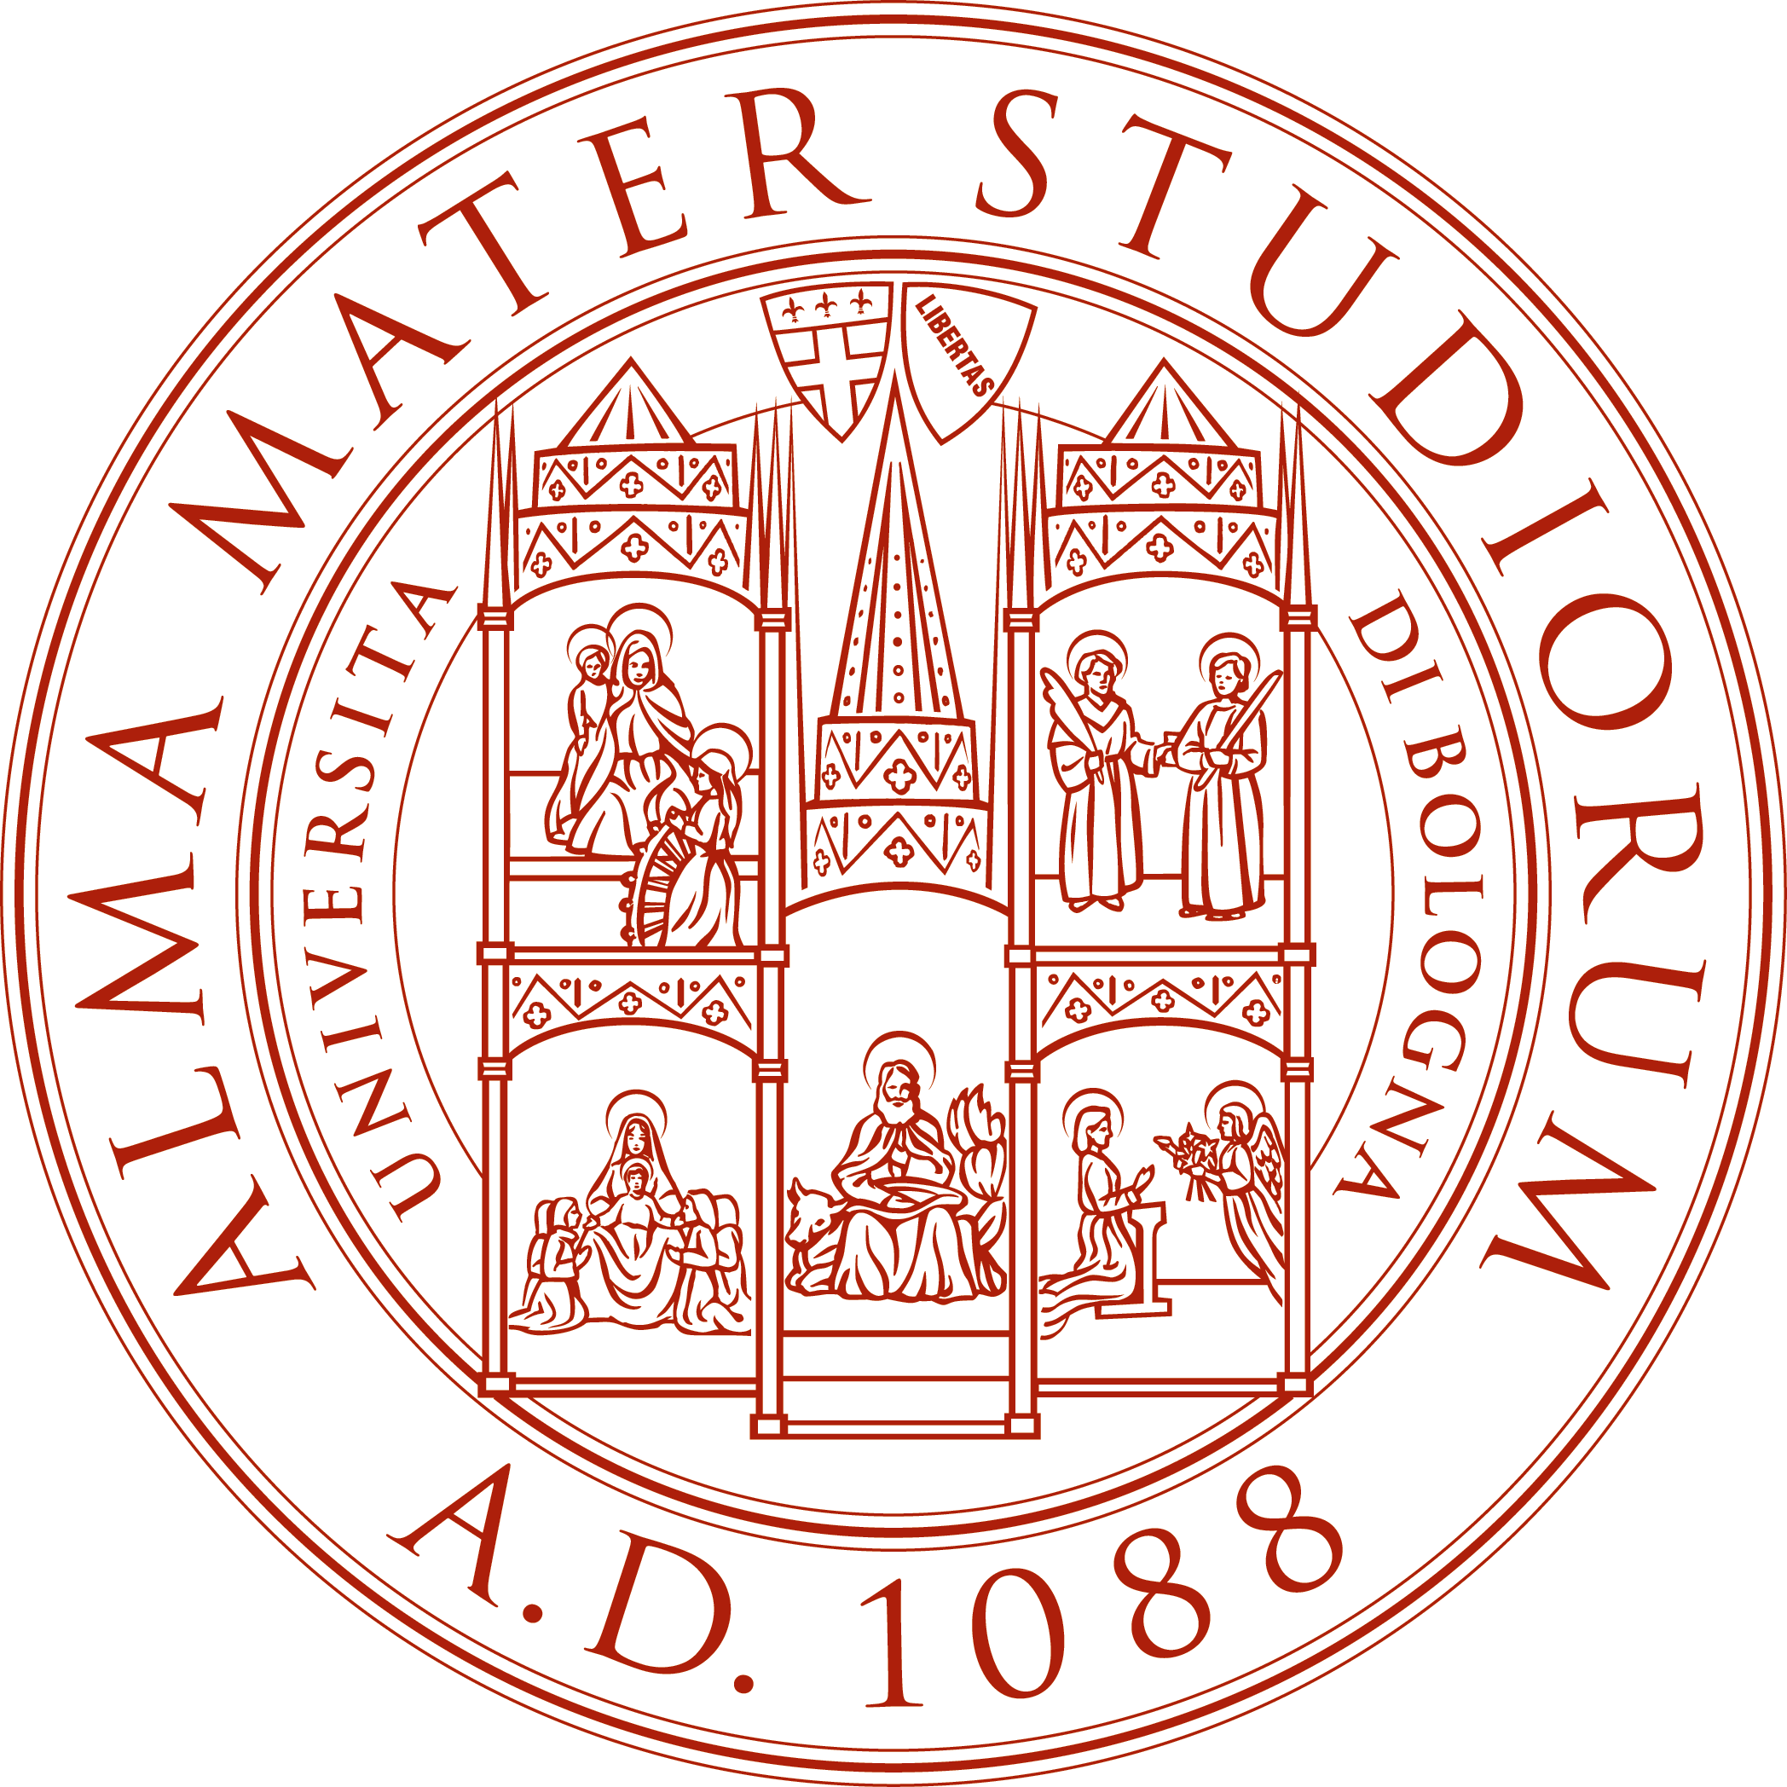
Alma Mater Studiorum – Università di Bologna
Centro residenziale Universitario Bertinoro (CeUB)

Italian Design Summer School: Art, Society and Industry (IDSS)

REGISTRATION FORM
Deadline for registration: May 31, 2025

1) Participant data

First Name: ___________________________________________________________

Last Name: ___________________________________________________________

Address: _____________________________________________________________

City: ____________________________Country: _____________________________

E-mail: ______________________________________________________________

Date of birth: _____________________ Cellular number: ______________________

City, province and country of birth: (for insurance reasons please list details)

____________________________________________________________________

Gender: Female Male

Nationality: __________________________________________________________

Passport number: _____________________________________________________

2) Education and training information

University: ___________________________________________________________

Faculty: _____________________________________________________________

Bachelor degree program Master degree program Ph.D.

In (subject): __________________________________________________________

Language competence:

English Basic Good Excellent

Other languages: ______________________________________________________

Computer skills:

Applications: Word Excel CAD 2D CAD 3D

- Solid Edge Photoshop Illustrator

Others: _____________________________________________________________

Average Level: Basic Good Excellent

Work experience: ______________________________________________________

____________________________________________________________________

____________________________________________________________________

How did you get to know about the IDSS: my University Website

FaceBook LinkedIn Instagram Twitter colleagues/friends other

Do you have any food allergies? No Yes

If YES, please specify ___________________________________________________

3) Registration Fee:

Registration fee Euro 2,280

The enrolment is considered effective only after the payment of the fee.
Deadline for registration and fee payment: May 31, 2025

Accommodation at Bologna and Bertinoro residences in double or triple room.
Single rooms might be available at both locations paying an extra fee. If you have this need, please let us know.

4) Method of payment:

Please make the payment of the registration fee to CeUB by bank transfer or credit card, following the procedure on the CeUB web site at
https://www.ceub.it/events/event/idss-italian-design-summer-school-art-society-and-industry-8/
In case of motivated cancellation, exceptionally, some refund will be given.

------------------------------------------------------------------------------------------------

This form must be completed and returned by e-mail before the registration deadline (31/05/2025) together with the copy of the passport, or another identity document if passport is not yet available at the day of the registration, to the following address:

din.itadesign@unibo.it

NOTE - Applicants will always receive confirmation of receipt. If you do not receive this, it means that your e-mail was not delivered correctly. In this case, please resend the form and await confirmation.

For administrative matters please refer to:
Dr. Roberta Partisani, administrative secretary of IDSS
Centro Residenziale Universitario di Bertinoro
Via Frangipane, 6 47032 Bertinoro (FC) – Italy
Telephone +39 0543 446500 – Fax +39 0543 446557
E-mail: rpartisani@ceub.it

Further information is available on the web site: http://italiandesign.ing.unibo.it

